# Dynamics, Heat Transfer, and Simulation Lab

This Arduino-based lab teaches heat transfer, dynamic simulation, and process control. Cost of each lab is about $20.

Python source: <http://apmonitor.com/pdc/index.php/Main/ArduinoTemperatureControl>

MATLAB source: <http://apmonitor.com/che436/index.php/Main/PhysicalLab>

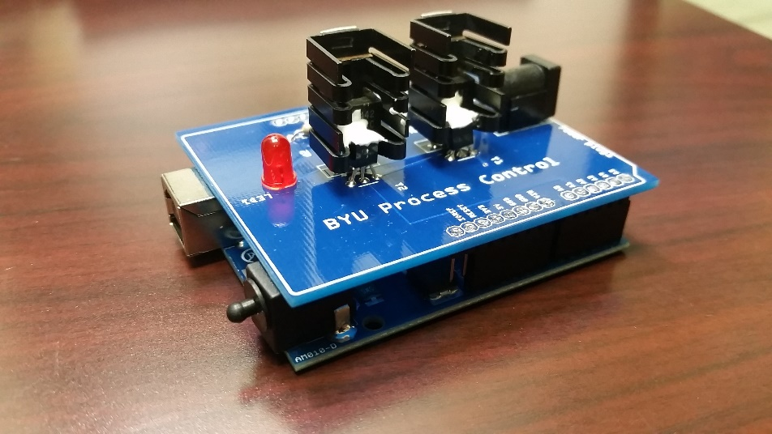

## Step 1: Dynamic Modeling

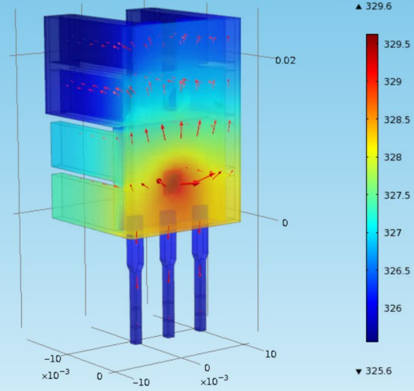The three important elements for a control loop are the measurement device (thermistor temperature sensor), an actuator (voltage to the transistor), and capability to perform computerized control (USB interface).

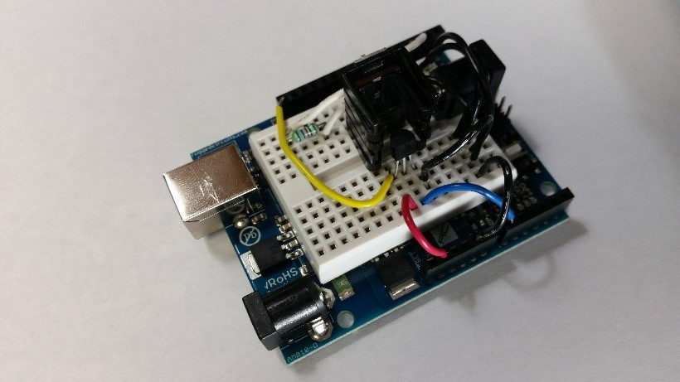

At maximum output the transistor dissipates 3.1 W of power with a voltage of 8.9 V and current of 0.35 A. The transistor is controlled with a 0 to 255 mV signal that linearly adjusts the power output between 0 and 3.1 W.

Create a dynamic model of the dynamic response between input power to the transistor and the temperature sensed by the thermistor. Use an energy balance to start the derivation.

Expand or simplify terms that are needed for this application. Develop a dynamic simulation of the temperature response due to an impulse (off, on, off) in the heater output. Leave the heater on for sufficient time to observe nearly steady state conditions.

## Step 2: Generate Data, Fit Physics-based Model

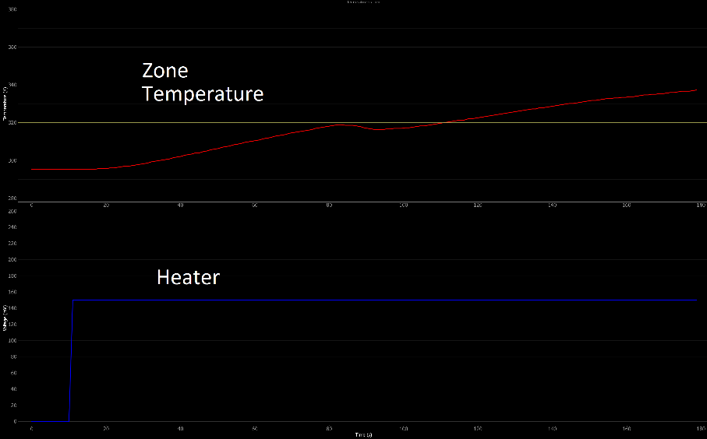

As done in simulation, test the same heater impulse response on the Arduino device and record the temperature. Adjust the uncertain parameters from Step 1 to best match the dynamic data from the impulse response.

## Step 3: Fit Dynamic Model

Using the data from Step 2, determine the parameters of a dynamic model that best match the dynamic temperature data.

## Step 4: PID Control

Obtain PID tuning constants from [**IMC correlations**](http://apmonitor.com/pdc/index.php/Main/ProportionalIntegralDerivative). Use the tuning constants for PID control of temperature. Demonstrate step changes in temperature set point and comment on the performance of the controller using the calculated constants. Tune the controller by adjusting the constants to improve performance. Comment on the difference between IMC tuning constants and the improved tuning constants in terms of rise time, overshoot, decay ratio, heater fluctuations, or other relevant performance criteria.